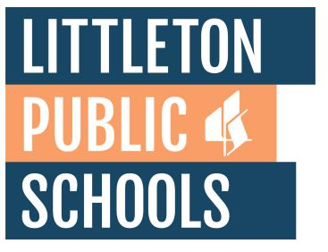  - imagine yourself  as a graduate student  Partnership in CLDE with Regis University  This program is designed for teachers in Littleton Public Schools to provide graduate classes in Culturally and Linguistically Diverse Education.  You can start to earn your Masters of Arts in Education with a CLDE added Endorsement. Affordable with multiple learning formats.  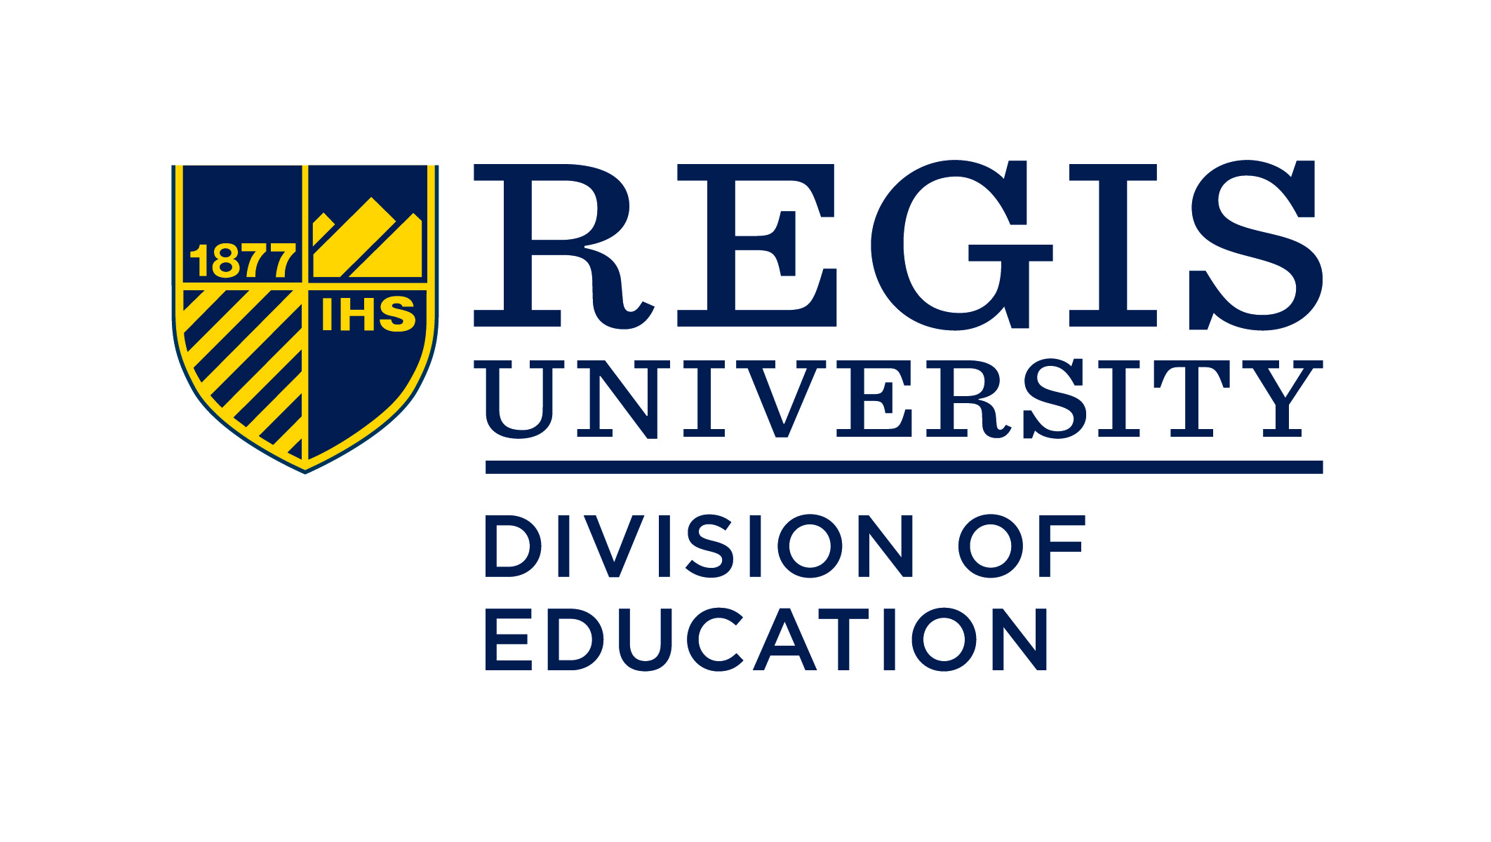  Pre-recorded Information Session:  Regis CLDE graduate information session 2022 VIDEO.mp4 | You love supporting your students and classroom... Now it is your chance to lead  ____  Learning formats- online only or synchronous meeting virtually one evening a week  ____  Summer, Fall & Spring starts  ____  Federal TEACH Grant  ____  10% tuition discount for licensed teachers  Contact  Kimberly Berry  CLDE Program Advisor  Regis University  kberry002@regis.edu

