Parent Portal
Report Cards

The parent portal Reports tab allows parents to generate reports of information such as report cards. The reports that are available are determined by each school and may change from time to time within the school year.

These reports generate in PDF format using Adobe Acrobat Reader.

Below are screen shots of what it looks like when logged into the parent portal.

- Click on Reports on the left hand side Navigational tool.
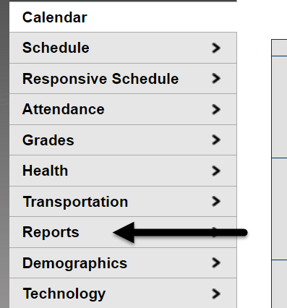

- Click on the available trimester report card.

